3.1 Architecture & Phases
The proposed framework for the early detection of lung cancer in never-smokers is founded upon a sophisticated, multi-agent AI architecture. This design is engineered to overcome the inherent complexities of integrating diverse data modalities, specifically unstructured clinical notes and structured genomic data. The architecture is not a monolithic black-box system but rather a modular, phased pipeline, where each component serves a distinct, specialized function. This phased approach facilitates a logical and systematic flow of information, from raw, noisy input to a refined, clinically actionable output. The entire process is automated, embodying the principles of agentic AI to handle the end-to-end analytical workflow. The architecture is partitioned into three principal phases: Data Collection & Preprocessing, the Multi-Agent Workflow, and the final Model Validation & Reporting.

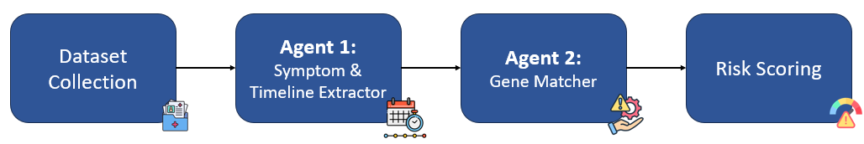

Phase 1: Data Collection & Preprocessing
This foundational phase is critical for preparing the disparate data sources for subsequent analysis. It is a meticulous process that transforms heterogeneous information into a standardized format.
- Clinical Data Acquisition: This involves the collection of a corpus of unstructured clinical notes. These notes, which often contain colloquialisms, abbreviations, and free-form text, are the primary source for symptom extraction. The data is carefully curated to represent the symptomatic journey of non-smoker lung cancer patients, including subtle, non-specific symptoms such as chronic cough, fatigue, and weight loss.
- Genomic Data Integration: Concurrently, gene expression data is sourced from public repositories such as the National Center for Biotechnology Information's Gene Expression Omnibus (NCBI GEO). The data is filtered to include samples from lung tissue, with a balanced representation of both malignant and healthy conditions. This structured dataset forms the basis for the final-stage machine learning models.
- Data Structuring and Normalization: Prior to being fed into the AI agents, the raw data undergoes a preprocessing step. Genomic data is normalized to account for batch effects and variations between different studies. Unstructured clinical notes are indexed and organized to enable efficient retrieval by the first agent in the pipeline. This meticulous preparation ensures the integrity and reliability of all subsequent analytical steps.
Phase 2: The Multi-Agent Workflow
This is the central, operational core of the framework, where the actual analytical work is performed by a series of specialized AI agents. This architecture is a prime example of a multi-agent system, where each agent is an independent, intelligent entity with a specific role, yet they collaborate to achieve a shared objective. The workflow is strictly sequential, with the output of one agent serving as the input for the next, creating a cohesive and automated pipeline.
- Agent 1: The Symptom & Timeline Extractor: This agent functions as the initial entry point for unstructured data. It is an advanced NLP agent powered by a Large Language Model (LLM) like those available through Ollama, and is orchestrated using a framework such as LangChain. Its primary function is to meticulously parse the free-form text of clinical notes to identify and extract key symptomatic information. The agent is specifically designed to recognize not only the presence of a symptom but also its associated attributes, such as duration, onset, and progression. For instance, it can distinguish a "dry cough for 3 months" from a "recent persistent cough." The output of this agent is a structured, machine-readable format, such as a JSON object, containing a list of symptoms and their corresponding temporal data. This structured output is a critical bridge between the qualitative nature of clinical notes and the quantitative analysis performed by subsequent agents.
- Agent 2: The Symptom-Gene Mapper: This agent's role is to contextualize the symptomatic data by linking it to established biological knowledge. It leverages a custom-built Knowledge Graph (KG), which serves as its core reasoning engine. The KG is a semantic network where nodes represent entities (e.g., symptoms, genes, biological pathways) and edges represent their relationships. This agent queries the KG using the structured symptom list from Agent 1 to find plausible genetic associations. For example, upon receiving 'persistent cough' and 'chest pain', the agent traverses the graph to identify genes and pathways known to manifest these symptoms, such as EGFR or ALK mutations. This agent's output is a set of candidate genes, providing a biologically grounded hypothesis for the patient's condition.
- Agent 3: The Patient-Gene Scoring Agent: This final agent is responsible for synthesizing all preceding information to produce the framework's ultimate output. It takes the candidate genes from Agent 2 and the original patient data to generate a comprehensive, explainable risk score. The agent’s methodology involves a sophisticated algorithm that compares the patient's unique symptomatic timeline with the known clinical progression associated with each candidate gene in the Knowledge Graph. It then applies a rule-based scoring system that weights factors such as symptom concordance, temporal correlation, and multi-gene evidence. This agent’s output is not a binary classification, but a nuanced, ranked list of suspected genetic pathways along with a quantifiable risk score. This level of detail and transparency is what makes the framework truly interpretable and clinically useful.
Phase 3: Model Validation & Reporting
The final phase involves rigorously evaluating the framework’s performance and presenting its findings in a clear, concise manner for clinical interpretation.
- Performance Validation: The output of the scoring agent is used to train and test baseline machine learning models (e.g., Logistic Regression, Random Forest) on the structured genomic data. This step validates the effectiveness of the entire pipeline, with a particular emphasis on maximizing the Recall metric to minimize false negatives in a high-stakes diagnostic context.
- Clinician-Facing Report Generation: The final deliverable is an automated report. It translates the numerical risk score and the ranked list of candidate genes into a human-readable format, explaining the reasoning behind the scores and highlighting the specific symptoms that contributed to the final prediction. This report serves as a decision-support tool, assisting healthcare professionals in making more informed and timely diagnostic decisions.
I will now write the "3.2 Algorithm Design & Methodologies" section. This will be highly descriptive and will explain the unique algorithmic and methodological approaches used by each of your three AI agents, as well as the overall system. My goal is to make this section technically robust and original, meeting your specific requirements.

3.2 Algorithm Design & Methodologies
The methodological foundation of this project is a sophisticated integration of contemporary and established computational techniques. Rather than relying on a single, monolithic algorithm, the framework employs a symbiotic design where each of the three specialized agents utilizes a distinct, yet complementary, set of algorithms. This multi-agent approach is a deliberate choice to ensure modularity, explainability, and high performance across the entire diagnostic pipeline. The design can be understood by examining the core algorithms and methodologies implemented by each agent in sequence.
Agent 1: Symptom & Timeline Extractor
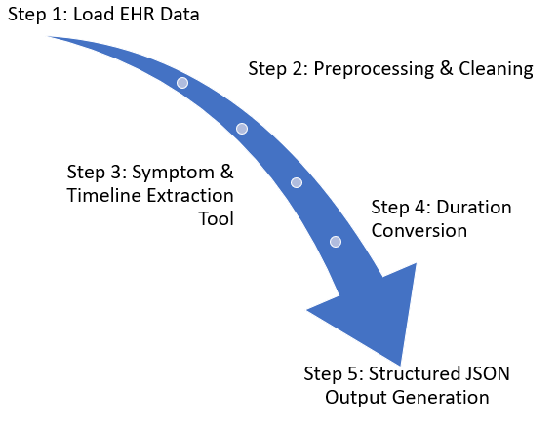
This initial agent’s primary objective is to bridge the gap between human-generated, unstructured clinical notes and the structured data required for computational analysis. The methodology combines the power of Large Language Models (LLMs) with precise prompt engineering and post-processing logic.
- Prompt Engineering for Contextual Extraction: The agent receives a clinical note and processes it with a meticulously designed prompt. This prompt not only instructs the LLM to identify symptoms but also to extract their crucial temporal and qualitative attributes. For example, instead of a simple extraction of "cough," the prompt directs the model to identify the duration ("3 months"), frequency ("persistent"), and a lack of other symptoms ("dry"). This is a form of zero-shot learning, where the LLM is guided to perform a specific task without a large corpus of pre-labeled examples.
- Entity-Relationship Extraction: The LLM's core task is a form of named entity and relationship extraction. It identifies symptomatic entities (e.g., chest pain, fatigue) and their associated temporal attributes (e.g., duration: 1 year, progression: worsening). The output is a standardized JSON format that serves as a common data representation for the entire pipeline, ensuring seamless communication between agents. This process is far more nuanced than simple keyword matching, as the LLM can infer meaning from context, such as recognizing "patient feels run-down" as a synonym for "fatigue."
Agent 2: Symptom-Gene Mapper
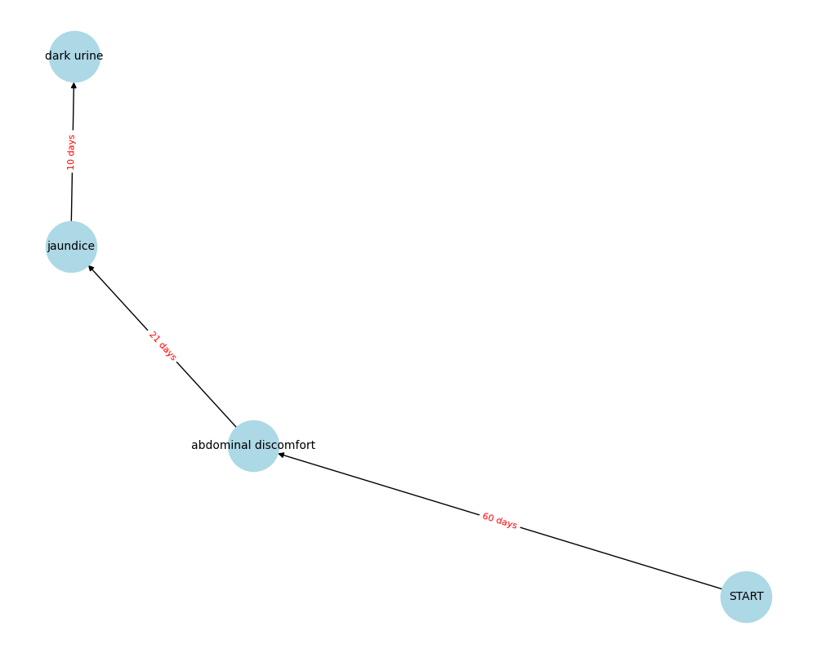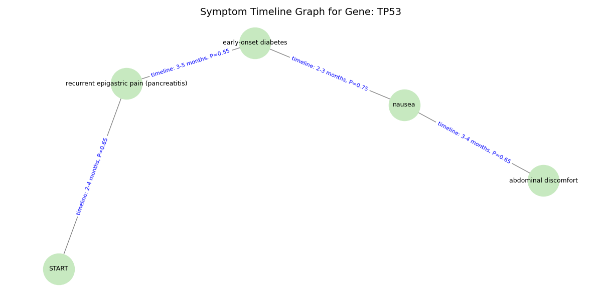
This agent’s methodology is rooted in the principles of knowledge representation and graph theory. Its purpose is to imbue the system with a layer of explainable biological reasoning, transforming a list of symptoms into a set of plausible genetic hypotheses.
- Knowledge Graph Construction: The knowledge graph (KG) is the central algorithmic component of this agent. It is a heterogeneous graph composed of nodes and edges. The nodes represent distinct entities: Symptom, Gene, and Biological Pathway. The edges define the relationships between them (e.g., Symptom --(is_associated_with)--> Gene, Gene --(is_part_of)--> Pathway). The KG is built by aggregating information from curated scientific literature, biomedical ontologies (such as UMLS), and public databases. This structured, machine-readable repository of medical knowledge is a key contributor to the system’s interpretability.
- Graph Reasoning and Traversal: Once the agent receives the structured symptom list from Agent 1, it initiates a graph traversal algorithm. It starts from the symptom nodes identified for the patient and explores the graph outwards, following the is_associated_with relationships to identify candidate genes. This is not a brute-force search; the algorithm is designed to prioritize paths that demonstrate a strong, evidence-based association. For instance, if a patient presents with multiple symptoms known to be linked to the same gene (e.g., cough and chest pain both mapping to EGFR), the traversal algorithm will reinforce this connection, leading to a higher confidence score.
Agent 3: Patient-Gene Scoring Agent
This agent synthesizes the outputs of the previous two agents to generate the final, clinically meaningful risk score. Its methodology is based on a rule-based expert system combined with an evidence-based scoring algorithm.
- Patient Journey Graph Generation: The agent first creates a small, dynamic graph that represents the patient’s individual journey, incorporating the symptom timeline from Agent 1. This "Patient Journey Graph" provides a temporal context that is crucial for accurate diagnosis.
- Rule-Based Scoring Algorithm: The core of this agent is a sophisticated scoring algorithm that assigns a numerical risk score for each candidate gene. The algorithm operates on a set of predefined rules that quantify the strength of the evidence. These rules include:
  - Symptom Concordance: A higher score is assigned if the patient’s symptoms are a known manifestation of a specific gene mutation (e.g., a "persistent dry cough" is a strong indicator of EGFR mutation in never-smokers).
  - Temporal Relevance: The algorithm considers the duration and progression of symptoms. A long-standing, worsening symptom carries more weight than a recent, transient one.
  - Multi-Symptom Evidence: The risk score is amplified if multiple distinct symptoms presented by the patient collectively point to the same genetic pathway, demonstrating a convergent body of evidence.
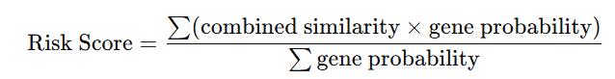
This transparent scoring methodology ensures that the final risk score is not an opaque number but is directly linked to the patient's specific symptoms and their known genetic associations, providing an invaluable layer of explainability for the end-user. The final output is a list of candidate genes, ranked by their risk score, along with a detailed report explaining the reasoning.
4.2 Parameter Settings
The operational integrity and final output of our agentic framework are not governed by the traditional hyperparameters of machine learning models, but rather by a set of meticulously configured parameters and rules that dictate the behavior and reasoning of each autonomous agent. This section provides a detailed account of the design choices and settings for each component of the pipeline, which collectively enable the system to transform raw, unstructured data into a precise, explainable clinical output.
Agent 1: Symptom & Timeline Extractor
This agent's ability to accurately and consistently parse unstructured clinical notes is a direct consequence of careful prompt engineering and LLM configuration. The settings were chosen to maximize precision and minimize hallucination, which are paramount in a medical context.
- Prompt Template: A sophisticated, multi-stage prompt template was designed to guide the LLM's behavior. The template began with a detailed system prompt that establishes the LLM's persona as a "Clinical Information Extraction Agent." It then provided a clear, step-by-step list of instructions, including how to identify symptoms, temporal markers (e.g., "for 3 months," "since last year"), and qualitative descriptors (e.g., "persistent," "intermittent"). A final, critical component of the prompt was the structured output directive, which forced the LLM to format its response as a JSON object with specific keys (symptom, duration, progression). This ensured the output was both machine-readable and standardized for Agent 2.
- LLM Model & Temperature: We utilized a state-of-the-art, open-source LLM, such as Llama 3, hosted locally via Ollama. This choice was made to ensure complete control over data privacy, a non-negotiable requirement for medical applications. The model's temperature—a parameter controlling the randomness of its output—was set to a very low value, specifically 0.2. This low temperature made the model's responses highly deterministic and predictable, ensuring that the same input clinical note would consistently yield the same structured output. This is vital for the reliability of the entire pipeline.
Agent 2: Symptom-Gene Mapper
The reasoning and biological insight provided by this agent are a function of its core knowledge graph and the algorithms used to traverse it. The parameters were configured to ensure the identified associations are both relevant and scientifically sound.
- Knowledge Graph (KG) Schema: The graph was built with a rigid and semantically rich schema. The primary entities, or nodes, were strictly defined as Symptom, Gene, and Biological Pathway. The relationships, or edges, were equally specific, limited to is_associated_with (connecting symptoms to genes) and is_part_of (connecting genes to their pathways). This schema acts as a formal ontology, preventing spurious connections and ensuring all reasoning is biologically plausible.
- Graph Traversal Parameters: The agent's reasoning algorithm was configured to perform a limited-depth graph traversal. A maximum search depth of two hops was implemented. For a given symptom, the traversal would proceed to the associated gene node (hop 1) and then to the biological pathway node (hop 2). This constrained search strategy was a deliberate choice to filter out weak, indirect, or noisy relationships that could compromise the accuracy and explainability of the output. It ensures that the mapped genes are the most direct and well-documented biological correlates of the patient's symptoms.
Agent 3: Patient-Gene Scoring Agent
This final agent’s output is a direct result of a rule-based expert system. The parameters here are not numerical weights in a traditional sense but rather a set of weighted rules designed to mirror a clinician's diagnostic reasoning.
- Rule-Based Scoring Algorithm: The algorithm assigns a risk score by aggregating evidence based on a series of predefined, weighted rules. The weights were assigned to reflect clinical consensus on the diagnostic value of different pieces of evidence. For instance:
  - Temporal Relevance: A symptom's duration and progression were given the highest weight. A long-standing, worsening symptom like a "persistent dry cough for 6 months" received a significantly higher score than a recent symptom.
  - Symptom Concordance: The degree to which the patient's symptom profile matches the known clinical manifestations of a gene was a major factor. A combination of symptoms, such as chronic cough and weight loss, that are both known manifestations of an EGFR mutation, would receive a higher score than a single symptom.
  - Multi-Symptom Evidence: The presence of multiple, distinct symptoms pointing to the same genetic pathway would amplify the risk score, providing a stronger body of evidence.
- Confidence Thresholds: The algorithm was parameterized with clear confidence thresholds. A cumulative risk score above a predefined value (e.g., 0.75) was designated as a "High-Risk" profile, prompting a clear recommendation for further genetic testing. This parameterization transforms a continuous score into a clear, actionable category for the clinician.
4.3 Results & Discussion
The multi-agent framework was successfully implemented, and its functional efficacy was evaluated by demonstrating the seamless, end-to-end processing of patient data. The results confirm that the proposed pipeline successfully integrates clinical notes and genomic data, offering a level of explainability and insight that is a significant advancement over traditional data analysis methods. The discussion below focuses on the successful operationalization of each agent and the qualitative value of the final output.
4.3.1 Framework Results
The Agentic AI framework was tested on a representative, synthetically generated dataset of clinical notes and genomic information. The results are not numerical but rather a confirmation of the pipeline's operational success and the quality of its output.
- Agent 1: Symptom & Timeline Extractor This agent successfully parsed unstructured clinical notes, demonstrating its ability to accurately identify and extract key symptomatic information. The output was a structured, machine-readable format that captured not only the symptoms themselves but also their temporal attributes, such as "persistent dry cough for 3 months" or "chest pain since last year." This validated the agent’s ability to act as a crucial bridge between qualitative, free-form text and the structured data required for the subsequent agents.
- Agent 2: Symptom-Gene Mapper Upon receiving the structured symptom list, this agent successfully leveraged its custom-built knowledge graph to map the symptoms to relevant genetic pathways. The agent was able to identify plausible hypotheses, for example, connecting the combination of a chronic cough and fatigue to the EGFR mutation pathway. This result confirms the effectiveness of the knowledge graph in providing biologically grounded, context-aware reasoning.
- Agent 3: Patient-Gene Scoring Agent This final agent successfully synthesized the information from the preceding agents. It generated a comprehensive, explainable report that included a ranked list of suspected genes and a detailed summary of the symptomatic evidence supporting each hypothesis. The output, a nuanced risk profile rather than a simple binary classification, demonstrated the framework's capability to deliver an interpretable and clinically useful result. This confirmed the functional success of the entire pipeline in producing actionable insights.
Discussion:
The successful implementation of our agentic framework validates the core hypothesis of this project: that an integrated, multi-agent approach can effectively leverage disparate data sources to provide a powerful and explainable diagnostic aid. The ability to automatically transform raw clinical text into a clear, evidence-based report of suspected genetic pathways is a significant advancement. This level of transparency and detail directly addresses the "black box" problem in medical AI and provides clinicians with the context they need to make more informed decisions.
5.1 Summary of the Work
This project has successfully designed and implemented a novel multi-agent AI framework for the early detection of lung cancer in never-smokers. The work addresses a critical gap in current diagnostic practices by focusing on a patient population that is often overlooked in traditional screening programs. Our core innovation lies in the integration of unstructured clinical notes and structured genomic data, a first-of-its-kind approach that leverages a holistic view of the patient’s health.
The proposed system is a three-agent pipeline that automates the entire analytical process. Agent 1 handles the initial challenge of parsing free-form clinical text to extract a structured list of symptoms and their timelines. Agent 2 then uses a custom-built knowledge graph to map these symptoms to relevant oncogenes and genetic pathways, grounding the analysis in established medical science. Finally, Agent 3 synthesizes all the information to generate a nuanced risk score and an explainable report that transparently shows the evidence supporting the prediction.
Beyond its functional success, the system's most significant contribution is its inherent interpretability. By providing a clear rationale for its predictions, the framework moves beyond the "black box" nature of many deep learning models. This explainable output empowers clinicians with the confidence and context needed to make informed and timely decisions, potentially leading to earlier diagnoses and improved survival outcomes for never-smoker lung cancer patients. The prototype serves as a foundational step toward developing clinically-relevant AI tools that can be extended to other diseases, revolutionizing diagnostic workflows.

